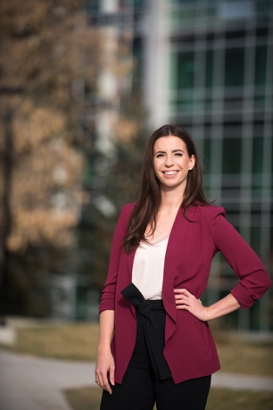

Dr. Lauren Roberts is a third-year resident in the Royal College Emergency Medicine program at the University of Saskatchewan. Before moving east, she completed medical school and a Master of Science in Epidemiology at the University of Calgary. Her academic interests include health services research, knowledge translation, and research methodology. She is passionate about improving medical education surrounding research and hopes to pursue a career as a clinician scientist. Outside of work, you can find her exploring outdoors with her partner Terry and their 13-month-old daughter Lennon.

