Biography – Dr Ferdie Smit
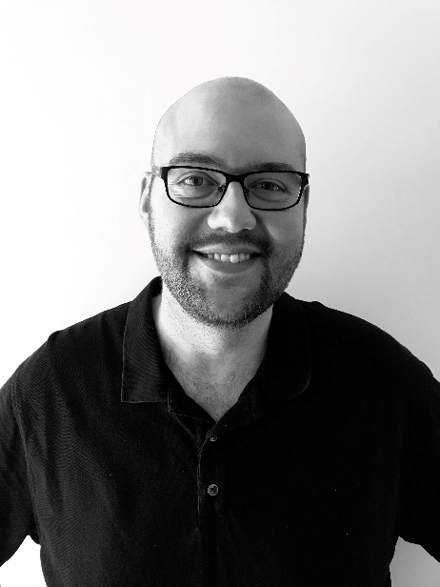
Dr Ferdie Smit was born in South Africa in 1982. He did his medical training at the University of Pretoria and graduated in 2006. What followed was a two-year medical internship in Cape Town and one year of Community Service as a surgical medical officer. He moved to Canada in 2010 and has been doing full-time Emergency Medicine since June of 2011 at the Victoria Hospital in Prince Albert. He challenged and passed the CCFP(EM) exam in 2016.

